Porphyry Cu Geochemistry Workshop
Part 3 Mineralogy from SWIR

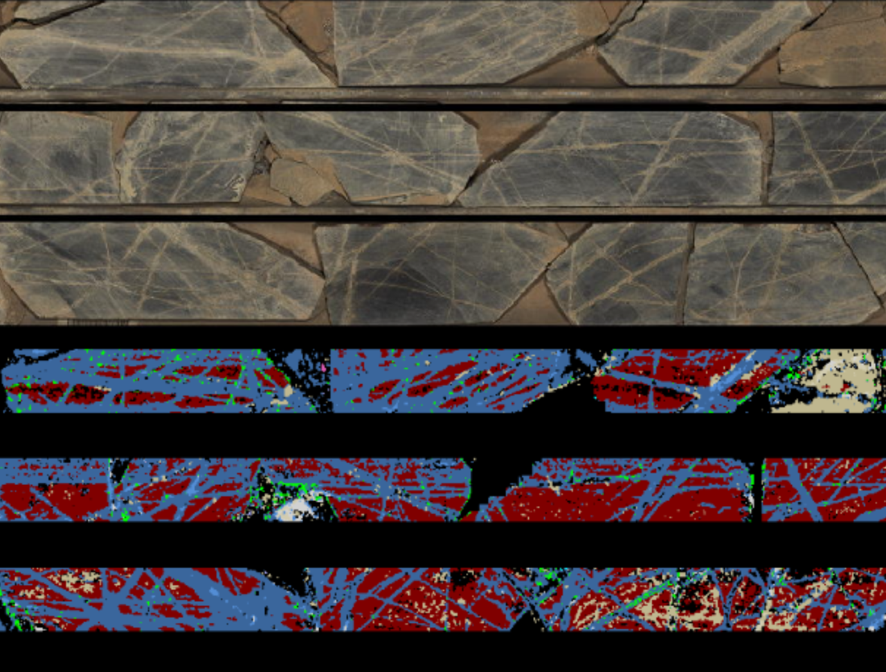

Scott Halley, 12/05/2021

Module 3: Combined chemical analyses and Corescan.
The objective of this exercise is to see how whole rock chemistry compares with SWIR data, and to understand the strengths and limitations of each method. This is the same data from the Alteration exercise in Module 2, but with Corescan results included. There are some components of the mineralogy that are best interpreted from the chemical analysis of major elements, and some things that are best measured from spectral data. Open the file Corescan Exercise.gas.
Workflow.
- Make probability plots of corescan mineral_pct, split by alteration type defined from wholerock assays.
- Colour the geochem alteration diagrams, (eg K/Al vs Na/Al, Al-K-Mg ternary, Ca-Fe-S ternary) by a colour stretch of 10 equal ranges of the corescan mineral_pct values
- Use the Corescan minerals as a series of “indicator” minerals of particular alteration environments, ranked from most important to least important, eg Biotite= proximal potassic, Alunite = proximal AA, Kaolinite = distal AA, etc.
The Corescan results are composited to match the assay intervals. One of the ways in which the Corescan data is presented is a numeric value that record the percentage of pixels in each assay interval containing each recognised mineral phase. These values are denoted as mineral_pct.
From the list of Variables, select Alunite, Aspectral, Dark_mica, Dickite, Chlorite, Fe_Oxide, Gypsum, Kaolinite, Montmorillonite, Pyrophyllite, Silica_opaline and White_mica. For these variables, create split probability plots, and then convert these to Cumulative Frequency plots.
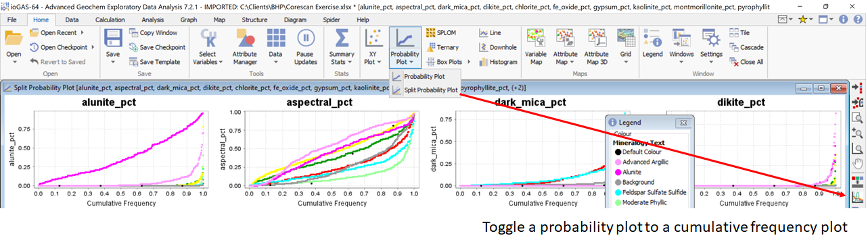

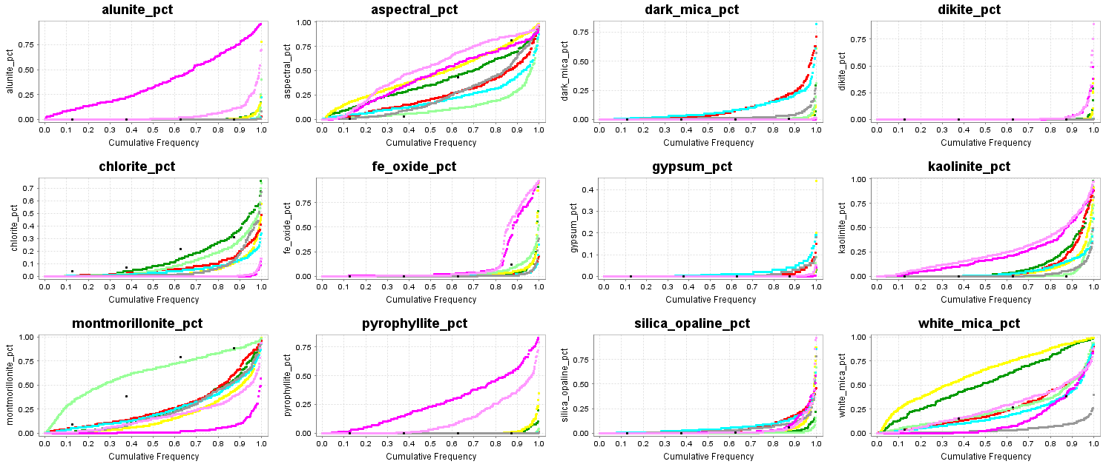
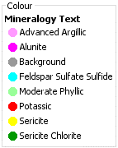
The cumulative frequency plots allow us to evaluate the way we interpreted mineralogy from major elements. Alunite was inferred from samples that were low in Ca and had S/Fe ratios higher than pyrite. Some of the samples picked as alunite bearing have low corescan alunite counts, but some of the advanced argillic rocks are reporting high corescan alunite counts.
“Aspectral” will include dark rocks and things with a high quartz, feldspar, or pyrite content. It is unexpected that rocks with a high sericite content for example should report high Aspectral values.
Biotite is a relatively weak infrared absorber, but SWIR methods still do a good job of recognising it. Relatively high biotite counts are reported in the Potassic and Feldspar_Sulfate groups as expected. If these rocks contained 5% to 10% by volume of hornblende phenocryst that had been replaced by biotite, then a dark_mica corescan percentage of as little as 3 to 4% is probably indicative of significant potassic alteration.
The proportion of dickite in this system is low. The advanced argillic aluminosilicates are dominated by pyrophyllite and kaolinite.
Some of the rocks identified from the chemistry as being chlorite-rich have a very low chlorite corescan percentage. The same can also be said for white mica.
Gyspum and anhydrite are weak infrared absorbers, and it looks like Corescan has done a poor job of identifying the sulfates. I suspect this is particularly true where the sulfates are in the groundmass rather than in veins.
Montmorillonite is difficult to interpret from assay data because most of the clays involve hydrolysis reactions with little change to the major element contents. It is common as shown in this data that many of the data points interpreted as partially sericitized samples are actually zones of argillic clay-rich alteration.
Now start looking at individual minerals and compare with the chemistry to assess whether corescan is identifying the correct features. In the Attribute Manager in the lower left corner, click the arrow for the drop-down box and select alunite_pct, a linear rainbow colour scheme and 10 equal ranges. This will colour the plots by the percentages of alunite pixels in each assay interval. Make a Ca-Fe-S ternary plot and see where the alunite-bearing samples plot on this diagram. Note what the mineral percentages are in each of the colour bins. The only significant alunite percentages are low Ca, with S/Fe > pyrite. There are low percentages of alunite interpreted in Ca-bearing samples that look like they should have anhydrite. It is most unlikely that there would be any alunite in Ca-bearing rocks.
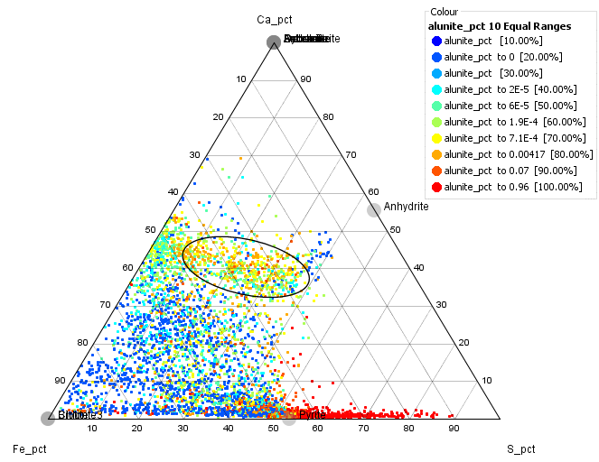

Next, change the colouring variable; make 10 equal ranges coloured by Aspectral. This shows that the samples reporting a high aspectral component are strongly pyritic or have a high feldspar component.

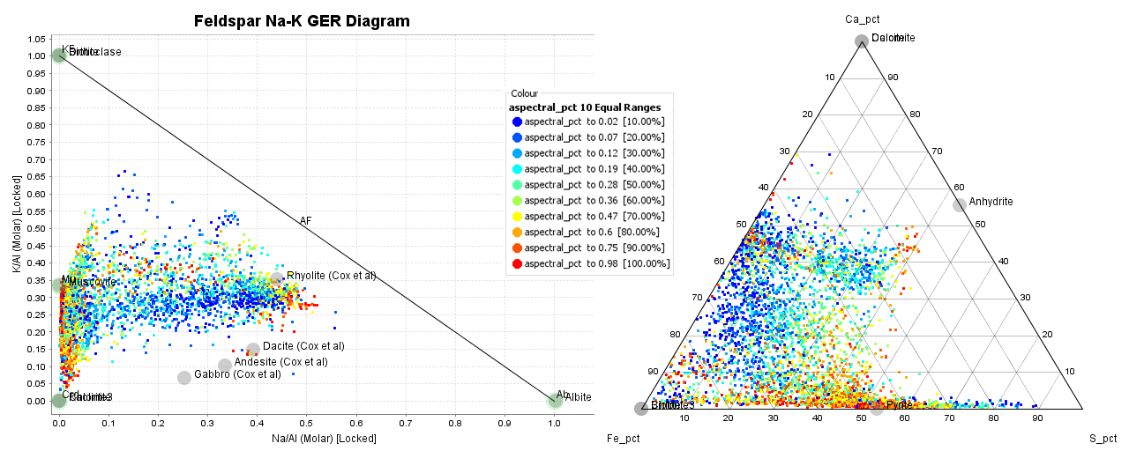

Next, create 10 equal ranges coloured by dark_mica_pct. Compare the patterns on the K/Al vs Na/Al, Al-K-Mg ternary and Ca-Fe-S ternary plots, and also note the percentage values in this colour spread. In particular look at the biotite contents along the anhydrite trend. It looks to me as though corescan is doing a particularly good job of picking biotite, most of the biotite occurs with anhydrite, and as a threshold for mapping potassic alteration, dark_mica_pct > 3% probably works well. (Biotite spectra have some similarities with hornblende, and I suspect that at low biotite_pct values, there may be some ambiguity).
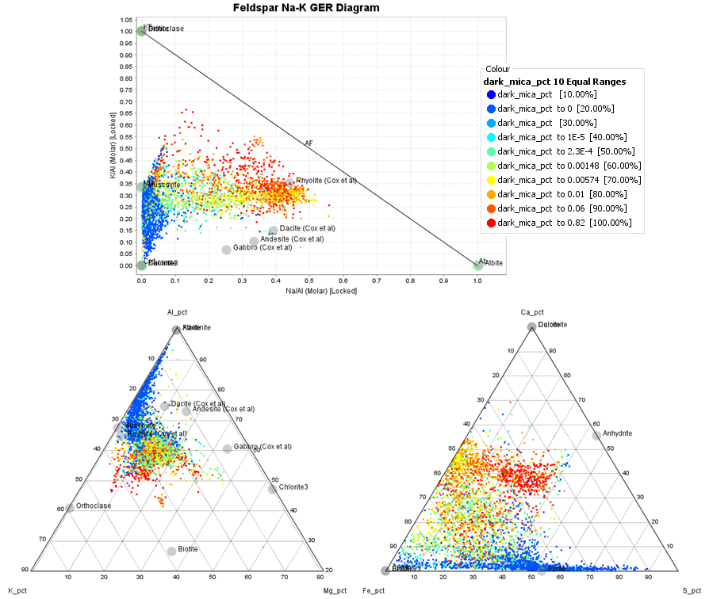

Make 10 equal colour ranges of chlorite_pct and look at the Al-K-Mg ternary plot. Some of these data points show unexpectedly low chlorite percentages (in the ellipse). Many of the low chlorite points are Na-depleted, but still contain Ca. I suspect there is a component of dolomitic carbonate in these rocks that has not been recognised in the spectra.
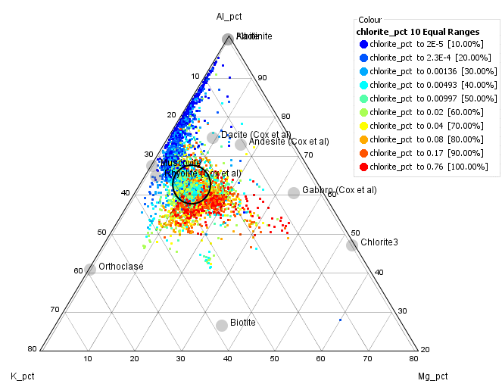
Next, make 10 equal ranges of kaolinite_pct. This shows that kaolinite occurs in 3 different environments! There is pervasive kaolinite in advanced argillic zones, kaolinite as part of an argillic overprint in potassic zones, and some kaolinite associated with distal K feldspar. This shows the power of merging the corescan with the assays; without the assays the significant of the 3 kaolinite environments is not recognised.
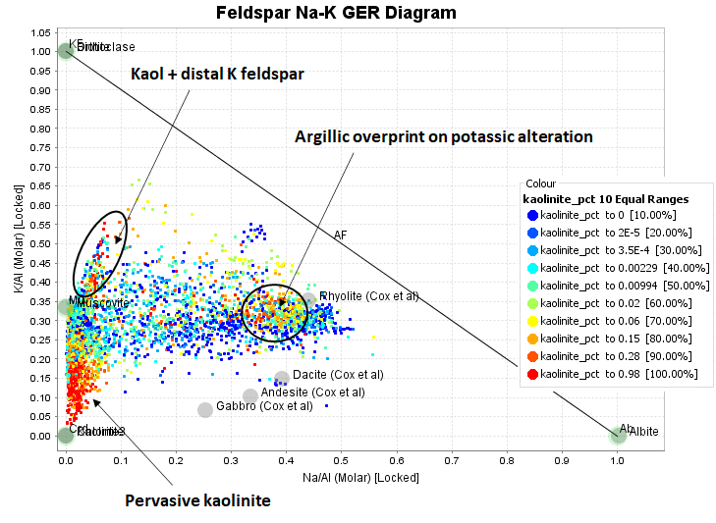
Next, create 10 equal colour ranges of pyrophyllite_pct. For values above 1% pyrophyllite, this is as expected. Tiny traces of pyrophyllite are reported from the potassic zone. This is highly improbably.
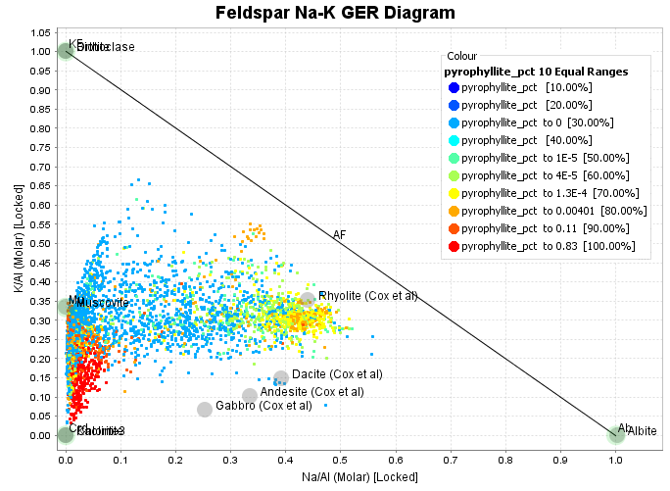
Next, create 10 equal colour ranges of montmorillonite_pct. The entire trend of data that appears to be partially sericitized is in fact clay altered. Smectite zones always retain some Na, Ca and Mg. These data points are trending towards an illite composition. Most smectites are Ca, Na bearing rather than potassic. Illite and montmorillonite form a complete continuum in their spectral responses. I suspect these are interlayered illite-smectites and there is a high degree of subjectivity in where the boundary between illite and montmorillonite is defined. In chemistry terms, more of these should have been defined as white mica.

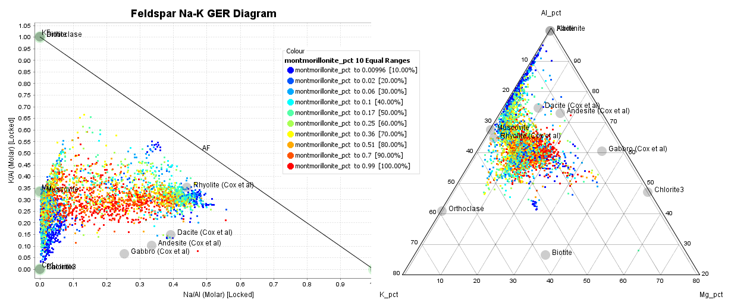

Next, create 10 equal colour ranges of white_mica_pct. This looks very much as expected and would be even better if the spectral definition of white mica versus montmorillonite was adjusted a little more in favour of white mica.
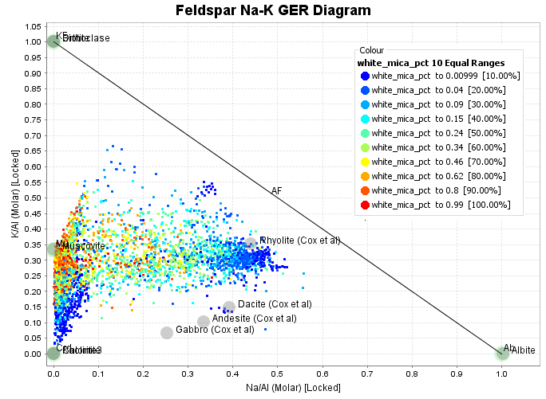

Create a Simplified Mineralogy Model from Corescan data
Every porphyry copper system has overprinting alteration assemblages. Potassic zones in porphyry Cu system always show some degree of overprinting with later fluids until the entire system has cooled to ambient temperatures. The example in the photo below has 3 different alteration assemblages superimposed. It has potassic alteration in the form of biotite replacing hornblende which probably formed around 400 degrees. It has phyllic alteration in the form of muscovite selvedges to quartz-pyrite veins which probably formed around 300 degrees. It has argillic alteration in the form of montmorillonite replacing relict plagioclase, which probably formed around 200 degrees. In a Corescan analysis, montmorillonite would report as the most abundant mineral, followed by white mica, and then biotite.
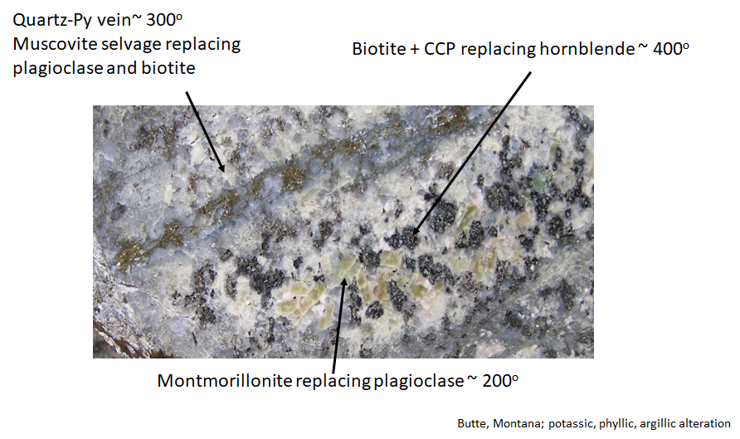
In an exploration context, the most important interpretation of this rock is that this is a really proximal sample; the potassic alteration shows we are in the center of the system.
In a geometallurgical context, the most important factor is the intensity and mineralogy of the overprinting minerals. The overprinting will modify the physical rock properties (ie, hardness, grindability), and will affect performance in the flotation circuit. We need to create models that are tailored for specific purposes. The workflow that I am going to present here is designed to create a mineralogical model for an exploration team.
What we should be doing with the Corescan data is to plot the pixel percentage values in 3D for each mineral to get an overview of the spatial distribution, but it is also important to make a coherent mineralogical model. For your deposit, decide on a priority sequence of minerals from hottest and most proximal, to coolest and most distal. Use the percentage of pixels per assay interval containing each mineral as a point count value. Pick a percentage of pixels for that mineral as a threshold to include those samples in a particular mineral zone. The previous section where we coloured the geochem alteration plots by 10 equal ranges of the mineral_pct values can be used to determine the significant threshold values for each mineral.
To make an exploration model from this data, I would use a priority list like this:
- Biotite
- Anhydrite,
- Alunite,
- Pyrophyllite,
- Dickite,
- Kaolinite,
- White Mica,
- Chlorite,
- Smectite
Make a cumulative frequency plot of dark_mica_pct. In the Attribute Manager, make a new colour group and call it biotite. Select the data points with dark_mica_pct => 4% and assign them to the Biotite category. The K/Al versus Na/Al molar ratio plot shows where these points are located.
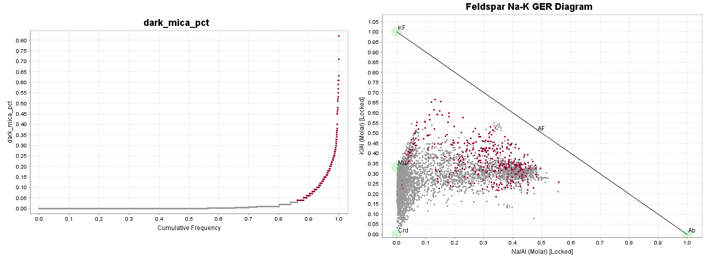
Once you have selected the Biotite points, turn them off. Make a cumulative frequency plot of Gypsum_pct. In the Attribute Manager, make a new colour group and call it Gypsum. Select the data points with gypsum_pct => 2% and assign them to the Gypsum category. The K/Al versus Na/Al molar ratio plot shows where these points are located.
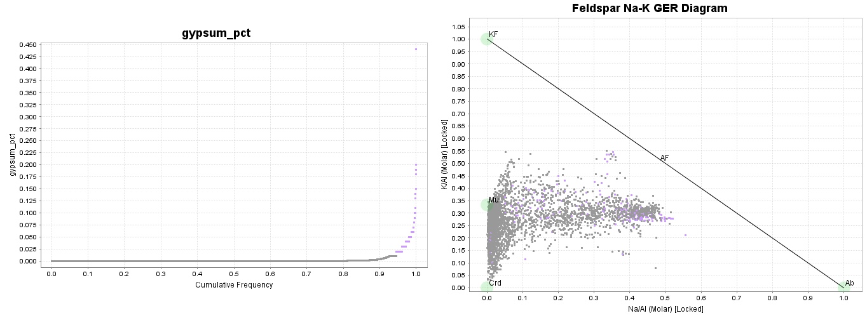
Once you have selected the Gypsum points, turn them off. Follow the same steps for Alunite. Make a cumulative frequency plot of alunite_pct. In the Attribute Manager, make a new colour group and call it Alunite. Select the data points with alunite_pct => 4% and assign them to the Alunite category. Make a Ca-Fe-S ternary plot to where these points are.
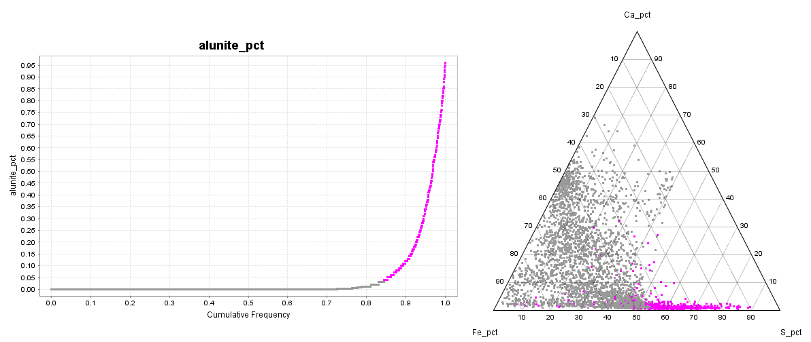

Once you have selected the alunite points, turn them off. Next select a pyrophyllite group. Follow the same steps for Alunite. Make a cumulative frequency plot of alunite_pct. In the Attribute Manager, make a new colour group and call it Alunite. Select the data points with alunite_pct => 4% and assign them to the Alunite category. Make a Ca-Fe-S ternary plot to where these points are.
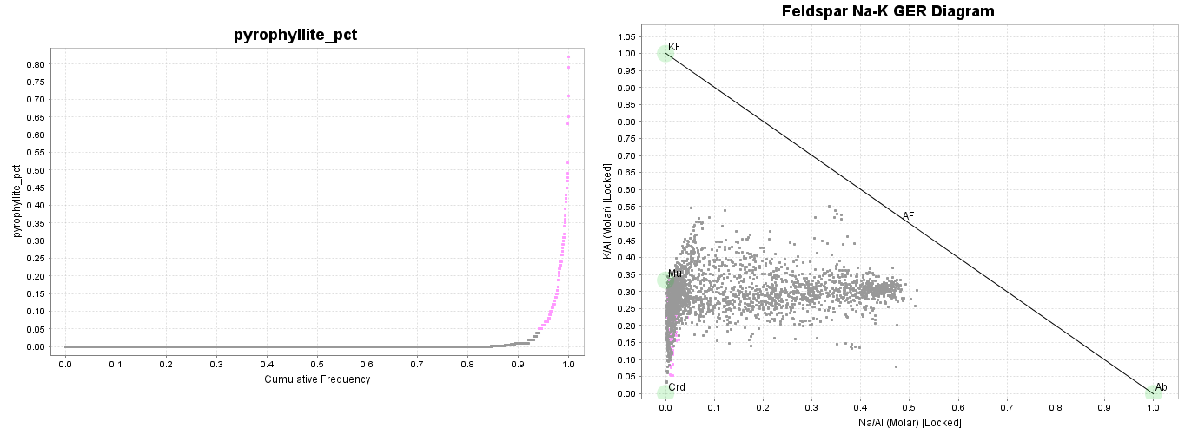
Repeat this process to select samples with white_mica > 40% from the remaining samples.
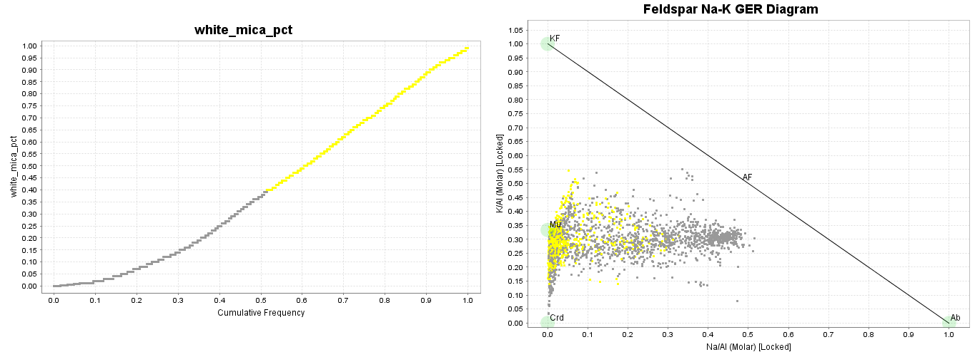

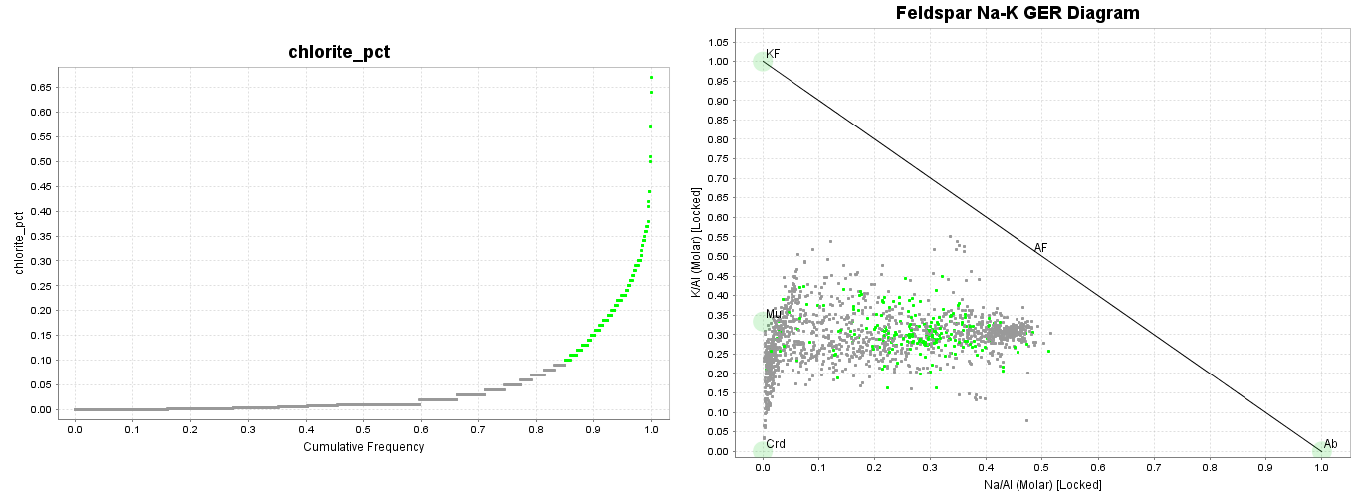
Repeat this process to select samples with chlorite > 10% from the remaining samples.

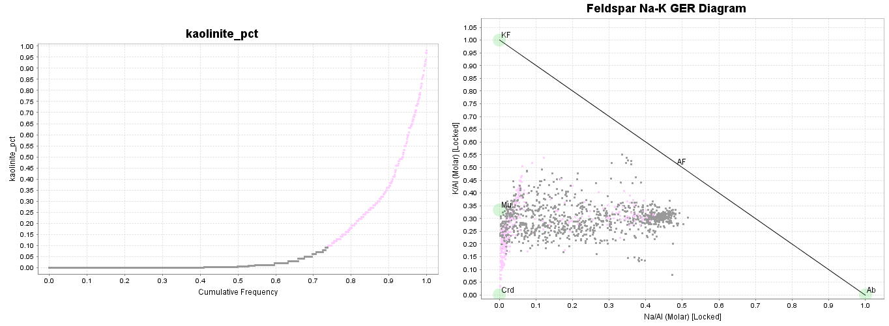
Repeat this process to select samples with kaolinite > 10% from the remaining samples.
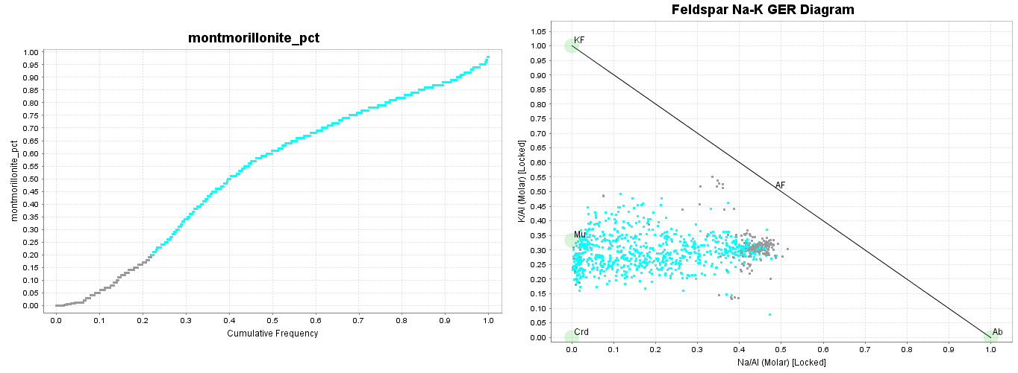
Repeat this process to select samples with montmorillonite > 20% from the remaining samples. Put all remaining samples into a group called NULL

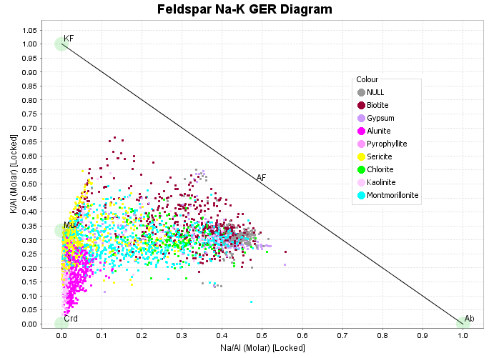
Turn all the data points back on. Examine the K/Al versus Na/Al molar ratio plot. This was a really simple way to deal with a complex data set, but this classification is a realistic overview of the data.
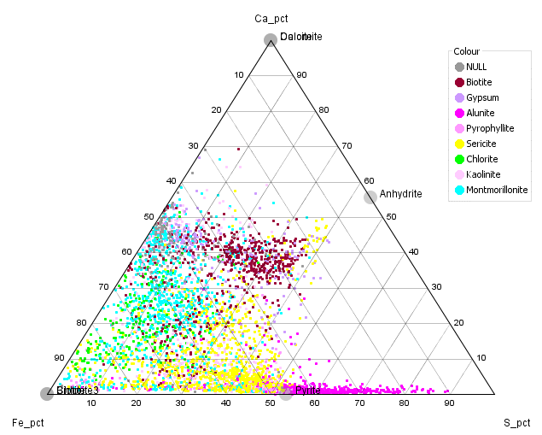
Examine the Ca-Fe-S ternary plot. Notice how the biotite and gypsum groups plot along the anhydrite trend. The NULL points generally have no S and plot midway along the Ca-Fe join. This is where unaltered rocks plot on this diagram.

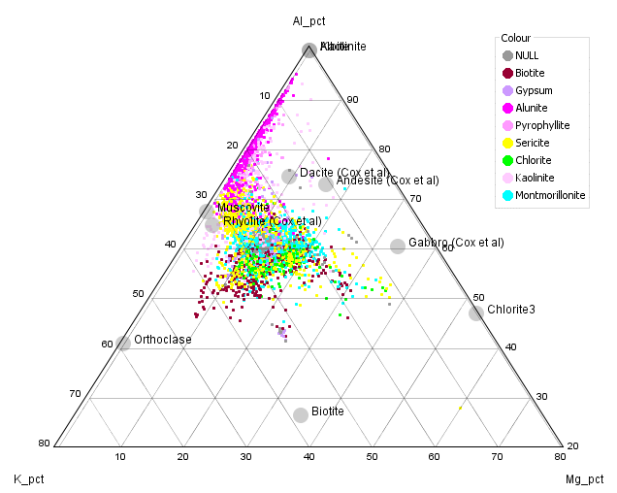
Examine the Al-K-Mg ternary plot. This clearly shows the low K and loss of Mg in the advanced argillic zones. Some of the chlorite group plots on the K-rich side of the chlorite-muscovite tie line. This could either be chlorite overprinting biotite in proximal areas, or chlorite with K feldspar in distal zones. Note also where the montmorillonite samples plot. This is a relatively weak argillic overprint, but even when the overprint is intense, smectite alteration never removes all the Mg, Na and Ca.
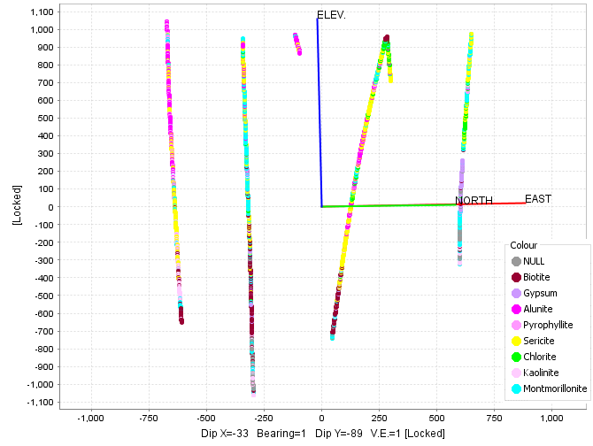
This is a cross section view of the simplified Corescan interpretation.
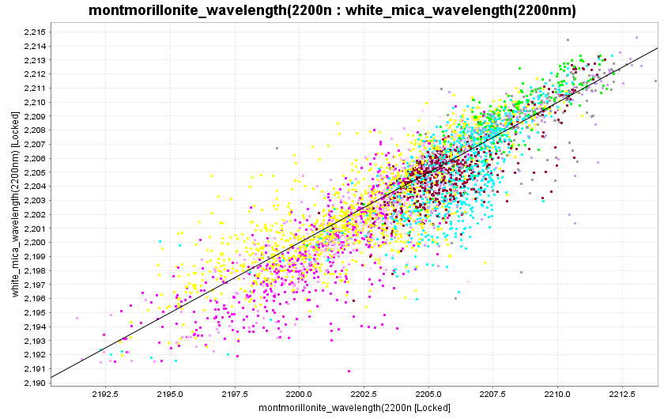
White mica has a diagnostic infrared absorption feature at around 2200nm.The wavelength of this absorption feature is variable, and is strongly correlated with the Tschermak substitution;
Al^{oct} + Al^{tet} (Fe, Mg)^{oct} + Si^{tet}
One of the outputs from Corescan is to extract the average Al-OH wavelength value for white mica within each assay interval. In this data set, they have also extracted the average Al-OH wavelength value for montmorillonite within each assay interval. Note they are strongly correlated. This highlights a discrepancy between processing of SWIR data from Corescan and The Spectral Geologist (aiSIRIS). TSG suggests the Al-OH wavelength in montmorillonite is fixed; always 2207nm. I wonder if the relationship above is another indication that the Corescan processing has not differentiated white mica from montmorillonite.
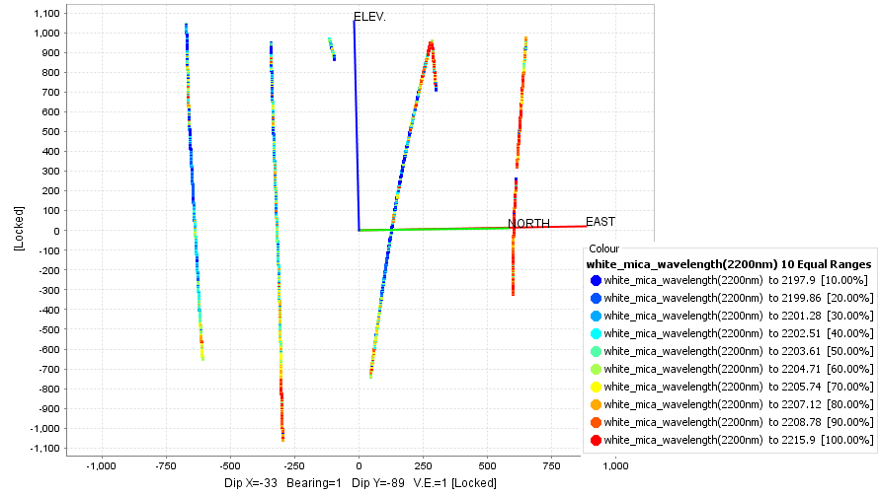
Colour the data points by 10 equal ranges of white_mica_wavelength. Note that the mica in or adjacent to the advanced argillic or intense phyllic alteration has wavelengths approaching stoichiometric muscovite at 2195nm. Mica that is part of the argillic overprint of potassic alteration or distal mica on the periphery of the phyllic alteration is more phengitic with wavelengths typically around 2210nm.

