Calculated Mineralogy versus Logged Mineralogy
Summary
In exploration and mining, we so often see different disciplines working in siloes. One group logs the core but only looks at copper or gold assays. Geochemists look at the assays without going back to the core. Geophysicists look at red to blue maps with no knowledge of mineralogy. Resource geologists rely on others to provide them with data.
If drill samples are assayed with a 4 acid digest ICP method, then there will be a huge amount of information in those assays which is rarely used to its full advanyage. Comet is an attempt to put an expert interpretation system into the hands of project geologists who may not have expert skills in geochemistry and mineralogy. This does not replace the need to log core or RC chips. Consistently recognizing all the minerals in drill samples is really difficult, and logging mineralogy quantitatively is impossible. If logging (+/- SWIR) is used to create a list of alteration minerals present in an exploration or mining project, then the Comet software can perform a mass balance calculation to quantify those minerals. Don’t blindly accept the output from the software. In every geochemistry dataset, there will be areas of ambiguity that need to be resolved by going back to the core. Creating a robust model is an iterative process between logging and chemistry.
This is a case study that compares visual logging with 4 acid digest ICP assays.
Read through this and decide for yourself how well the logged mineralogy matches the assay data, and see where the estimated mineral percentages derived from Comet are ambiguous.

Case Study
This case study is from a porphyry Cu system. It is a relatively old porphyry. Most of the metal is in a high sulfidation chalcocite-covellite-bornite lode, rather than in a classic “potassic” core. This porphyry had an extensive SCC (sericite-chlorite-clay) overprint and subsequently had lower to middle greenschist metamorphism. The effect of the metamorphism was to recrystallize the clay minerals.
The objective of this case study is to compare the visual observations of geologists (ie logging data) with quantitative, 4 acid digest ICP analyses. This is a discovery made by a small, highly skilled team of porphyry geologists. Most of the holes were logged by just 3 or 4 geologists, so variations in logging are not due to personal biases. Most of the drilling was RC, not core drilling. The purpose of the comparison is just to highlight how difficult it is to consistently identify minerals, let alone log in a quantitative fashion.
The assay table was merged with the logging table. The alteration was logged by assigning each assay interval to a category based on the dominant or diagnostic alteration mineral in that interval. There are 4 alteration diagrams that I commonly use;
K/Al vs Na/Al (molar)
Al-K-Mg ternary
Ca-Fe-S ternary
Ca-K-Na ternary.
I created each of these diagrams and coloured the data points by the logged mineralogy. In the alteration table, there were 33 different categories. I have shown just the most common groups.

K/Al vs Na/Al (molar)
This figure shows the relative amounts of white mica (around the muscovite node) and feldspars (towards the alkali feldspar line). Advanced argillic zones should plot between the muscovite node and the origin. With intense phyllic alteration, the yellow (sericite) points should cluster around the muscovite node. Many of these rocks are strongly Na-depleted. The rocks that contain primary and/or relict feldspars should define a distinct alteration type. This plot shows how difficult it is to visually log feldpsars!
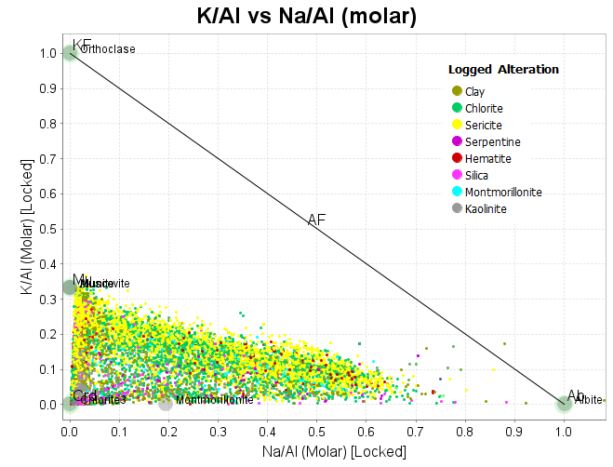
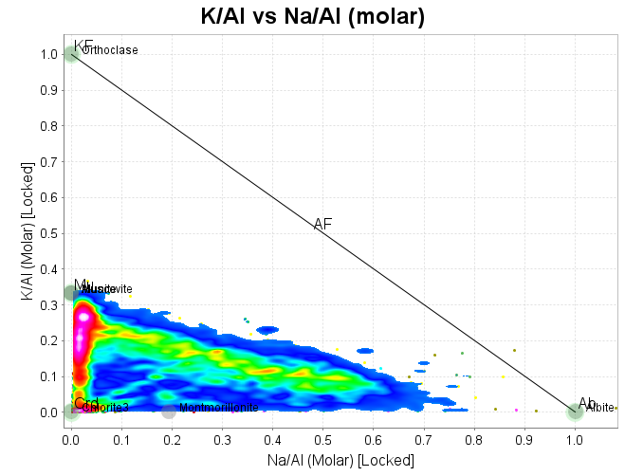

Al-K-Mg ternary
This plot shows the relative amounts of mica versus chlorite and/or biotite. There is a distinct edge to the data cloud between the muscovite and chlorite nodes. This is a mineralogical control. Along this line all the Al is in white mica and/or chlorite. On the Al-rich side of this line, there must be another Al-bearing mineral, eg albite, smectite, kaolinite. On the point density plot, there is a tight cluster of points near the muscovite node, a tail of points towards the chlorite node, and a large population of mixed sericite-chlorite.

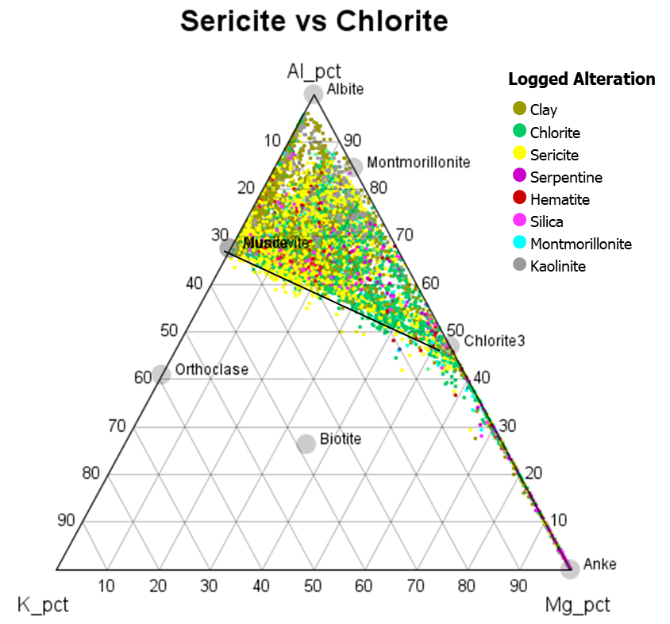
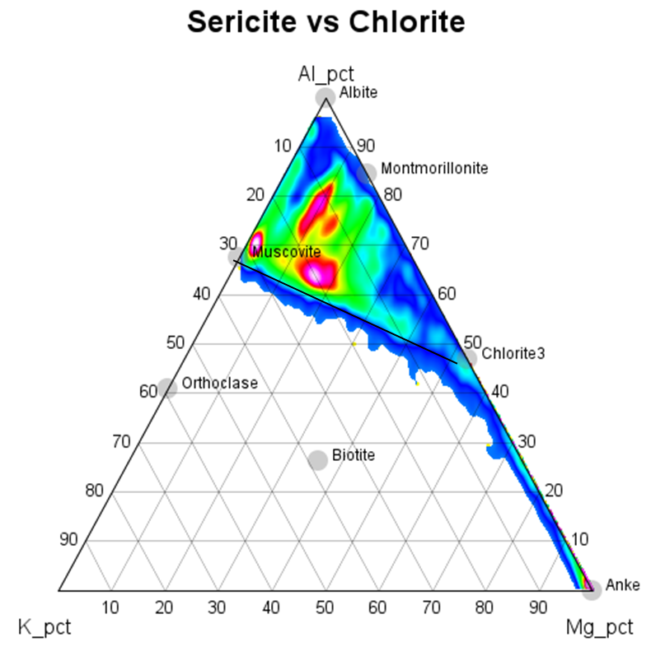
Ca-Fe-S ternary
Note the edge of the data cloud between the pyrite node and the anhydrite node. This is typical in porphyry systems; a range from albite + anhydrite to sericite + pyrite. Something that is unusual is the volume of data between the pyrite node and the Fe apex. This shows a spectrum of Fe minerals from pyrite to chlorite (+/-) Fe oxides in the weathering profile. This is unusual in porphyries because feldspar destruction (Ca-removal) is usually accompanied by pyrite addition. I suspect this system initially had far more anhydrite, but the sulfate was removed during the SCC event or during metamorphism.
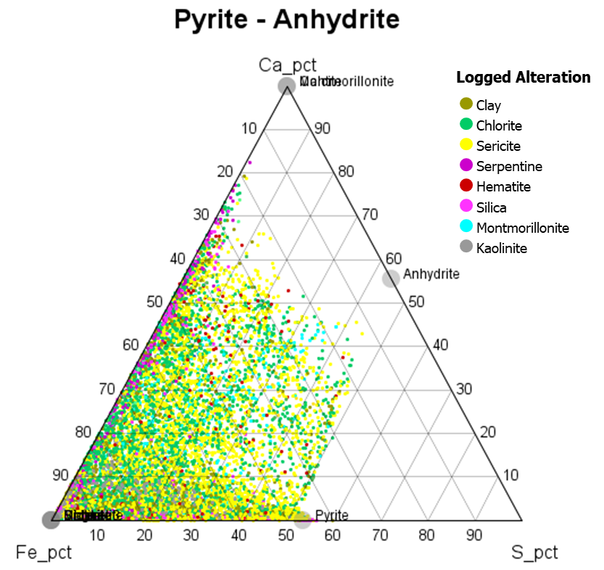
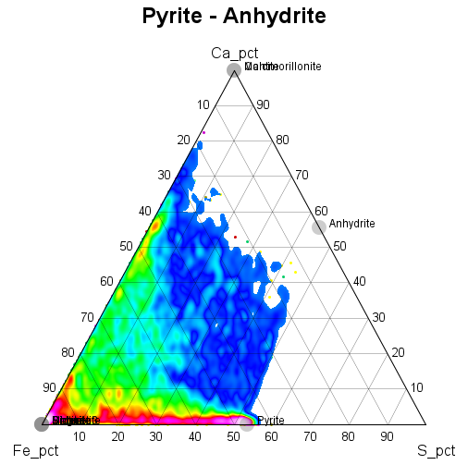
Ca-K-Na ternary.
The dominant reaction in the core of a porphyry system is plagioclase + SO2 = albite + anhydrite. The samples in the ellipse have had no net addition or loss of K, Na or Ca, but they could have anhydrite. The samples plotting along the Ca-K join have lost all their Na, but retained Ca as anhydrite. The samples plotting between K and Na have a component of albite, but they have lost a soluble Ca phase. Anhydrite or carbonate?
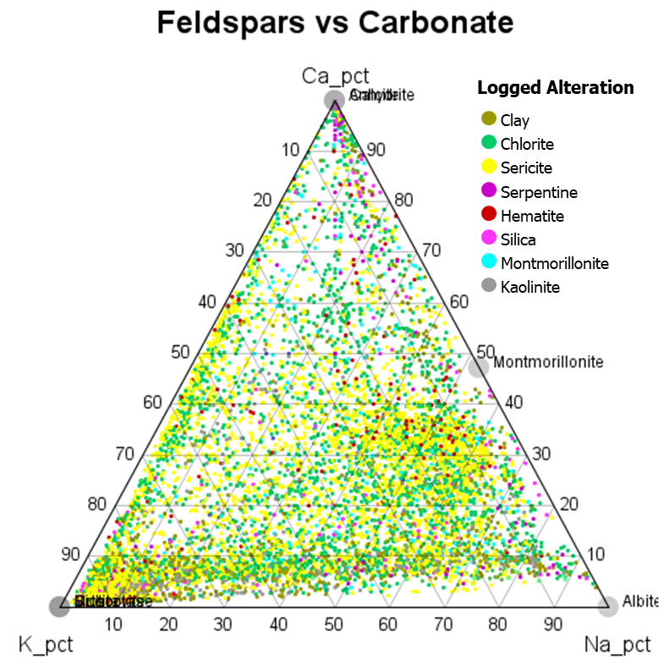
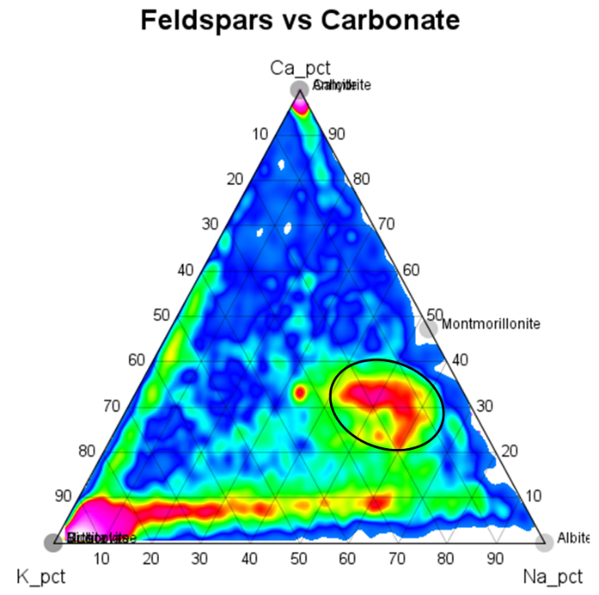

Muscovite
Calculated percentage of muscovite on an Al-K-Mg ternary. Highest values near the muscovite node, but decreasing towards the Al apex (albite, kaolinite) and the chlorite node.
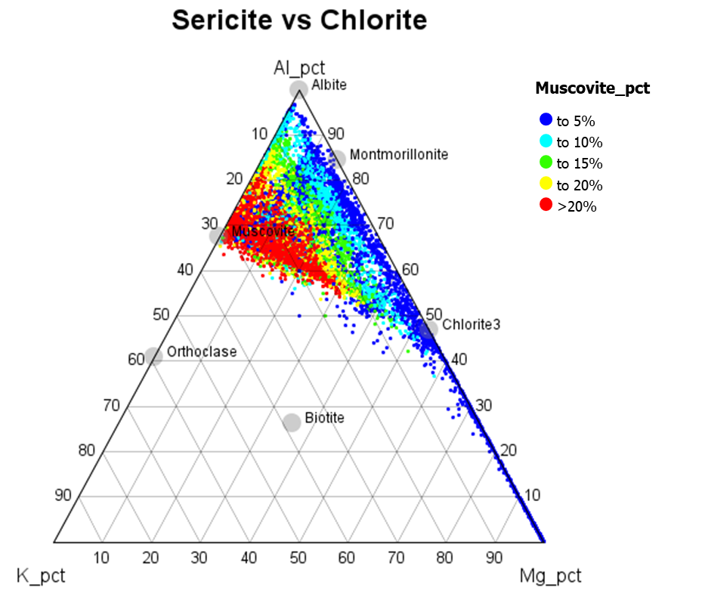
Calculated percentage of muscovite on a K/Al vs Na/Al molar plot. Highest values near the muscovite node, but decreasing towards the origin (kaolinite) and the albite node.
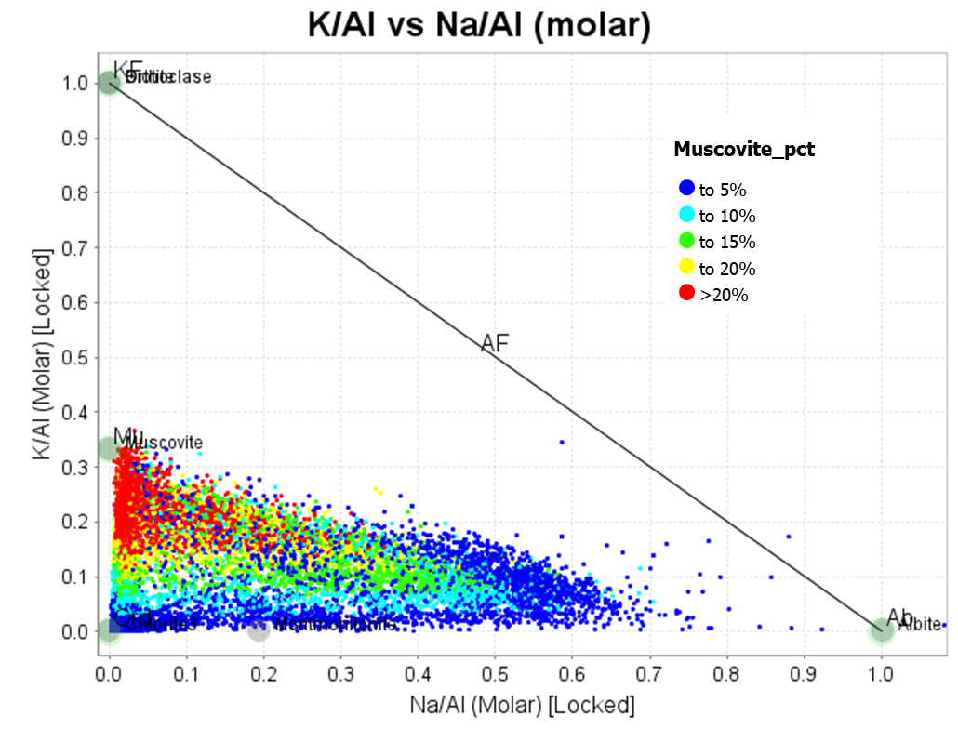
Chlorite
Calculated percentage of chlorite on an Al-K-Mg ternary. Highest values near the chlorite node, but decreasing towards the Al apex (albite, kaolinite) and the muscovite node. The trail of points to the Mg apex is an ultramafic rock with serpentine and dolomite.

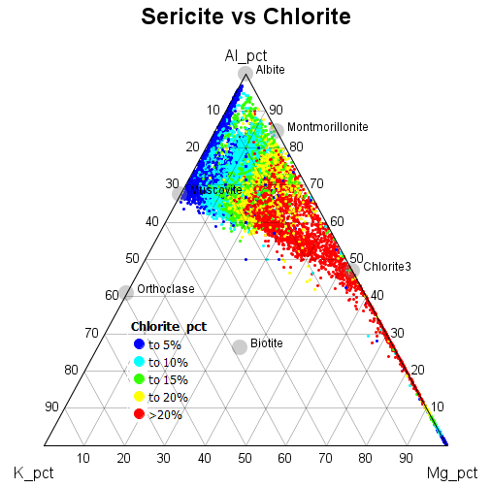

Feldspar
Total feldspar was calculated with 4 components; albite, orthoclase, plagioclase and a Ba component. These are low K rocks, so the orthoclase component is small. These are also for the most part, Ca depleted. The dominant relict feldspar is albite.
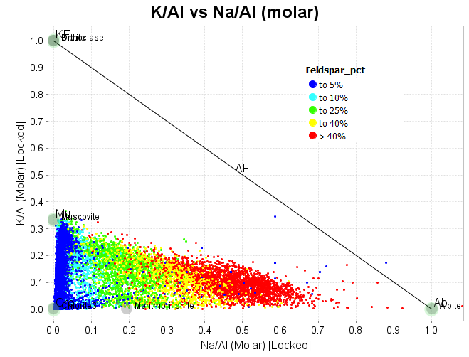

Quartz
Although the assay package does not include SiO2, the estimates of quartz are surprisingly accurate. The highest quartz contents are with strong phyllic alteration, advanced argillic, and in the leached saprolite.
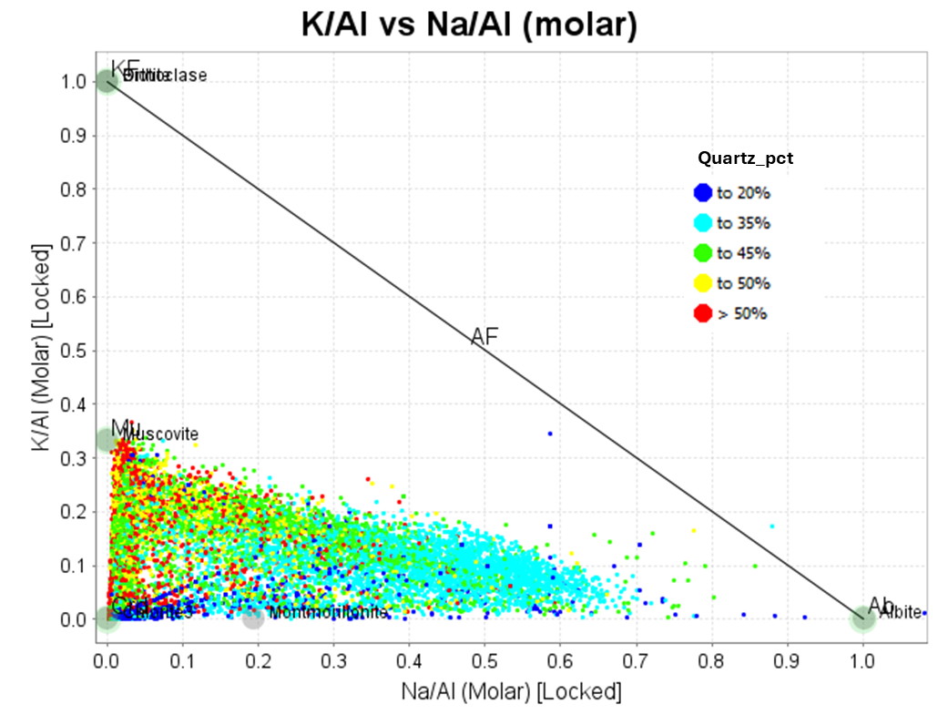

Pyrite
Use a Ca-Fe-S ternary to display estimated pyrite contents. Note how pyrite increases towards the pyrite-anhydrite tie-line and especially towards the pyrite node.
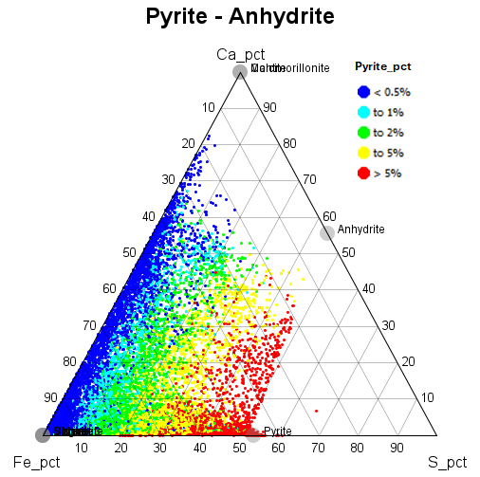
Anhydrite
Use a Ca-Fe-S ternary to display estimated anhydrite contents. As mentioned previously I think most of the anhydrite has been leached from this system.
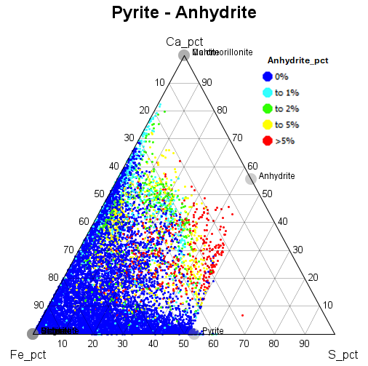
Kaolinite
On a K/Al vs Na/Al diagram, advanced argillic alteration is confined to the triangle defined by muscovite-paragonite-origin (or K alunite-Na alunite-origin). On this plot, the blue points within that triangle are the ultramafic rocks with inherently low K and Na. In this particular system, there is extensive kaolinite in the saprolite, hydrothermal kaolinite with chalcocite, and narrow structures at depth with pyrophyllite. The chemistry alone does not differentiate between those different occurrences.
